VIVEKANAND EDUCATION SOCIETY’S INSTITUTE OF TECHNOLOGY
(An Autonomous Institute Affiliated to University of Mumbai
Department of Computer Engineering)
Department of Computer Engineering


Project Report on

EduBridge: Agentic AI Framework for Inclusive Education

In partial fulfillment of the Fourth Year (Semester–VII), Bachelor of Engineering
(B.E.) Degree in Computer Engineering at the University of Mumbai Academic Year 2025-26

Project Mentor: Dr. Sujata Khedkar

Submitted by

Sarang Pavanaskar, D17A/51
Akshat Mahajan, D17A/40
Tanmay Maity, D17A/42
Mohit Vaidya, D17A/60

(2025-26)
VIVEKANAND EDUCATION SOCIETY’S INSTITUTE OF TECHNOLOGY
(An Autonomous Institute Affiliated to University of Mumbai
Department of Computer Engineering)

Department of Computer Engineering


CERTIFICATE of Approval

This is to certify that Sarang Pavanaskar (D17A-51), Akshat Mahajan (D17A-40), Tanmay Maity (D17A-42), Mohit Vaidya (D17A-60) of Fourth Year Computer Engineering studying under the University of Mumbai has satisfactorily presented the project on “EduBridge: Agentic AI Framework for Inclusive Education” as a part of the coursework of PROJECT-I for Semester-VII under the guidance of Dr. Sujata Khedkar. in the year 2024-2025.
01/11/2025
Date

__________________ |  | __________________
Internal Examiner |  | External Examiner

_________________ __________________ __________________
Project Mentor Head of the Department Principal
Dr. Mrs. Nupur Giri Dr. J. M. Nair

ACKNOWLEDGEMENT

We are thankful to our college Vivekanand Education Society’s Institute of Technology for considering our project and extending help at all stages needed during our work of collecting information regarding the project.

It gives us immense pleasure to express our deep and sincere gratitude to Assistant Professor Dr. Sujata Khedkar (Project Guide) for her kind help and valuable advice during the development of project synopsis and for her guidance and suggestions.

We are deeply indebted to the Head of the Computer Department Dr. (Mrs.) Nupur Giri and our Principal Dr. (Mrs.) J.M. Nair , for giving us this valuable opportunity to do this project.

We express our hearty thanks to them for their assistance without which it would have been difficult in finishing this project synopsis and project review successfully.

We convey our deep sense of gratitude to all teaching and non-teaching staff for their constant encouragement, support and selfless help throughout the project work. It is a great pleasure to acknowledge the help and suggestion, which we received from the Department of Computer Engineering.

We wish to express our profound thanks to all those who helped us in gathering information about the project. Our families too have provided moral support and encouragement several times.

Computer Engineering Department

COURSE OUTCOMES FOR B.E PROJECT

Learners will be to:-

Course Outcome | Description of the Course Outcome
CO 1 | Do literature survey/industrial visit and identify the problem of the selected project topic.
CO2 | Apply basic engineering fundamental in the domain of practical applications FORproblem identification, formulation and solution
CO 3 | Attempt & Design a problem solution in a right approach to complex problems
CO 4 | Cultivate the habit of working in a team
CO 5 | Correlate the theoretical and experimental/simulations results and draw the proper inferences
CO 6 | Demonstrate the knowledge, skills and attitudes of a professional engineer & Prepare report as per the standard guidelines.

ABSTRACT
EduBridge is an AI-powered learning assistant designed to simplify academic content and make self-learning more effective. It focuses on transforming complex study material into simplified notes, topic-wise summaries, mind maps, and flashcards. The platform aims to help students understand difficult subjects more easily while promoting independent learning. It uses Generative AI and Large Language Models (LLMs) to understand each learner’s needs, learning speed, and style. Based on this understanding, EduBridge creates customized lessons, gives real-time feedback, and helps students learn through text, images, and voice-based interaction.
The system focuses on bridging learning gaps between students by offering equal access to quality education, especially for those with special needs or different learning abilities. It also supports multiple languages and includes assistive features that make learning easier and more engaging for all. Teachers can use EduBridge to track student progress, get suggestions for improvement, and design better lesson plans with the help of AI.
By combining human teaching methods with intelligent automation, EduBridge aims to build classrooms where learning is more adaptive, interactive, and accessible. The goal of this project is to create a smarter education system that truly understands every learner and helps them reach their full potential.

INDEX
Chapter No. | Title | Page No.
1 | Introduction | 8-11
 | 1.1 Introduction to the Project | 8
 | 1.2 Motivation for the Project | 8
 | 1.3 Drawback of the Existing System | 9
 | 1.4 Problem Definition | 10
 | 1.5 Relevance of the Project | 10
 | 1.6 Methodology Used | 10
2 | Literature Survey | 12-15
 | 2.1 Research Papers Referred | 12
 | 2.2 Interaction with Domain Experts | 15
3. | Requirement Of Proposed System | 16-24
 | 3.1 Functional Requirements | 16
 | 3.2 Non-Functional Requirements | 17
 | 3.3 Constraints | 18
 | 3.4 Hardware & Software Requirements | 19
 | 3.5 Techniques Utilized till date for the Proposed System | 20
 | 3.6 Tools Utilized till date for the Proposed System | 20
 | 3.7 Algorithms Utilized in Existing Systems | 21
 | 3.8 Project Proposal | 23
4. | Proposed Design | 25-34
 | 4.1 Block Diagram Representation of the Proposed System | 25
 | 4.2 Modular Diagram Representation of the proposed System | 27
 | 4.3 Design of the Proposed System  a. Data Flow Diagrams  b. Flowchart for the Proposed System  c. Screenshots of Implementation | 29-34
 | 4.4 Project Scheduling & Tracking using Timeline / Gantt Chart | 34
5. | Proposed Results and Discussions | 35-37
 | 5.1 Proposed Output | 35
 | 5.2 Evaluation Parameters | 35
 | 5.3 Graphical Representations | 36
 | 5.4 Expected Outcomes | 37
6. | Plan Of Action For the Next Semester | 38-39
 | 6.1 Work Done Till Date | 38
 | 6.2 Plan of Action for Project II | 38
7. | Conclusion | 40
8. | References | 41
9. | Appendix | 42-51
 | 9.1 List Of Figures | 42
 | 9.2 List Of Tables | 42
 | 9.3 Research Paper | 43-50
 | 9.4 Review 1: Evaluation Sheet | 51
 | 9.5 Review 2: Evaluation Sheet | 51

CHAPTER 1: INTRODUCTION
This chapter provides an overview of the project, outlining its conceptual foundation and relevance. It begins by introducing the project’s central idea, followed by the motivation behind its development and the drawbacks of existing systems. The chapter further defines the problem statement, establishes the project’s significance in the current technological and social context, and concludes with a brief discussion of the methodology adopted for its implementation.

1.1 Introduction to the Project
Students with special educational needs (SEN) often face unique challenges in understanding and engaging with traditional learning materials that are designed for the general student population.
This project, entitled EduBridge: Agentic AI Framework for Inclusive Education, aims to bridge this gap by developing an AI-powered learning assistant that converts academic content into simplified topic-wise notes, mind maps, and flashcards. The system utilizes Natural Language Processing (NLP) and multimodal LLMs to simplify text, summarize content, and generate accessible learning materials in a visually engaging and easy-to-understand format.
The EduBridge framework is designed to function as a bridge between educators, students, and AI tools. It helps in transforming complex academic material into personalized learning resources based on individual learning preferences and comprehension levels. The project adopts an agentic AI approach, where the system does not simply respond to user input but proactively identifies knowledge gaps, curates relevant resources, and recommends adaptive learning materials.
The overall objective is to make learning inclusive, accessible, and self-paced, especially for learners with cognitive or learning disabilities, and to help educators create content that reaches every type of learner.

1.2 Motivation for the Project
Inclusive education is a global priority, yet implementing it effectively remains a significant challenge. Many educational systems are not equipped to address the diverse cognitive, linguistic, and social needs of students, especially those with learning disabilities such as dyslexia, ADHD, or autism spectrum disorders.
The National Education Policy (NEP) 2020 emphasizes equitable access to quality education for all learners, including those from underprivileged backgrounds. However, the current system largely depends on one-size-fits-all teaching methods and static resources.
The motivation for developing EduBridge stems from the growing need for personalized and adaptive learning tools. With advancements in AI, particularly NLP and generative models, it is now possible to design intelligent systems that can understand educational content and retransform it to match different comprehension levels.
Moreover, with the widespread use of digital platforms for learning, it becomes imperative to integrate tools that can support learners who face cognitive or linguistic challenges. EduBridge aims to stand at the intersection of technology, education, and inclusivity, promoting a system that not only teaches but understands how students learn best.

1.3 Drawbacks of the Existing System
The traditional educational ecosystem presents several limitations that hinder effective and inclusive learning. The key drawbacks are outlined below:
- Limited Accessibility:
Existing learning systems are not adequately designed for students with cognitive or learning disabilities. Educational content is text-heavy, and lacks simplified explanations.
- Low Engagement:
Conventional methods fail to maintain learner engagement, especially in online environments. Students often lose interest when exposed to lengthy or monotonous text-based material.
- Language and Comprehension Barriers:
Many academic resources are written in advanced or technical language that is difficult for beginners or learners with disabilities to comprehend.
- Lack of Personalization:
Traditional platforms adopt a uniform content delivery model, ignoring individual learning pace, interests, and comprehension levels.
- Minimal Teacher Assistance Tools:
Educators lack automated tools to transform their teaching content into simpler or more visual learning resources.
- Ineffective Feedback Mechanisms:
Most learning systems provide limited feedback and fail to adapt dynamically based on a learner’s progress.
- Limited Use of Modern AI Techniques:
Existing educational tools rarely utilize generative AI, NLP, or multimodal content generation for improving accessibility and interactivity.
- Scalability Issues:
Many inclusive learning approaches depend heavily on human intervention, making them difficult to scale for large groups of learners.
These drawbacks highlight the necessity for a technology-driven solution that enhances accessibility, personalization, and engagement — areas that form the foundation of EduBridge.

1.4 Problem Definition
In India, standardized school curricula often overlook the diverse learning needs of students with Special Education Needs (SEN). These students face challenges such as understanding advanced language, technical terms and abstract concepts.. This creates major gaps in accessibility, personalization, and engagement, making it difficult for SEN learners to fully benefit from classroom instruction.
EduBridge aims to solve this problem by developing an AI-powered framework that utilizes NLP and agentic AI to process and transform educational content into learner-friendly resources, thereby fostering inclusive education and reducing learning gaps.

1.5 Relevance of the Project
The relevance of this project lies in its alignment with both technological advancement and social responsibility. EduBridge supports the global push toward inclusive and adaptive learning systems, as envisioned by policies such as NEP 2020 and the United Nations’ Sustainable Development Goal 4 (Quality Education).
From a technological standpoint, it showcases the application of AI in education, particularly the integration of NLP and multimodal content generation. From a societal perspective, it emphasizes accessibility, empathy, and equal opportunity in education.
The system holds potential for application across schools, universities, and e-learning platforms, serving both mainstream students and those with special needs. It represents a meaningful step toward leveraging AI to make education more human-centered and inclusive.

1.6 Methodology Used
The development of EduBridge follows a systematic and modular approach:
- Requirement Analysis:
Identification of user needs (students and educators), system objectives, and target learning challenges.
- Data Collection:
Gathering educational content across multiple subjects and difficulty levels to serve as model input.
- NLP-Based Processing:
Using NLP techniques such as summarization, text simplification, and keyword extraction to transform content into more digestible formats.
- Agentic AI Framework:
Implementing an agent-based structure that proactively generates study aids like notes, mind maps, and flashcards, and adapts them based on learner interaction.
- Multimodal Output Generation:
Employing AI models to produce both text and visual formats to enhance understanding and retention.
- Frontend Development:
Building an intuitive, accessible, and responsive interface using React and Tailwind CSS for smooth user interaction.
- Backend Integration:
Utilizing Python and Flask for data processing, API handling, and interaction with the AI models.
- Testing and Evaluation:
Conducting usability testing and evaluating content accuracy, readability, and accessibility.
- Deployment:
Hosting the framework for real-world testing and collecting user feedback for iterative improvements.

CHAPTER 2: LITERATURE REVIEW
This chapter presents a detailed review of existing research and literature related to the proposed project. It includes summaries and analyses of research papers relevant to the study. Additionally, it discusses insights gained from domain experts.
2.1 Research Papers Referred
Year | Title | Abstract | Methodology | Inference Drawn
2025 | Generative AI in Education: From Foundational Insights to the Socratic Playground for Learning (Hu et al.) | The paper explores how generative AI can integrate with sound pedagogy to create adaptive, dialogue-driven learning experiences. It discusses AI’s potential to support inquiry-based education through Socratic dialogue. | Conducted a conceptual analysis of pedagogical theories and generative AI tools; proposed the Socratic Playground for Learning (SPL) as a framework for AI-assisted learning. | Informed EduBridge’s design of an interactive AI assistant that supports reflective and question-based learning.
2025 | SocratiQ: A Generative AI-Powered Learning Companion(Jabbour et al.) | This study introduces SocratiQ, an AI embedded within an online textbook to provide personalized explanations, quizzes, and study guidance. | Integrated the SocratiQ system into a Machine Learning Systems course; evaluated its effects on student engagement and learning outcomes through surveys and interaction analysis. | Validates the integration of intelligent tutoring within digital content — inspiring EduBridge’s embedded AI-based learning assistant.
2025 | LLMs as Educational Analysts: Transforming Multimodal Data Traces (Davalos et al.) | The paper demonstrates how large language models can analyze multimodal learning data (eye-tracking, performance metrics) to produce teacher-friendly insights. | Used AI agents with human oversight to interpret multimodal data and generate narrative assessment reports for educators. | Supports EduBridge’s adaptive feedback mechanism to analyze learning progress and tailor educational materials.
2024 | Collaborative AI-Enhanced Digital Mind-Mapping(Fang et al.) | Examines how AI-assisted mind-mapping can improve creativity and learning outcomes in inclusive classrooms, especially for neurodiverse learners. | Conducted an experimental study with 163 higher education students (including 28 with NDDs) using AI-enhanced Mindomo software; analyzed pre/post creativity tests. | Reinforces EduBridge’s use of AI-generated mind maps to support visual and inclusive learning for diverse student groups.
2024 | NEXT-GPT: Any-to-Any Multimodal LLM (Wu et al.) | Presents a multimodal large language model capable of processing and generating text, image, audio, and video outputs seamlessly. | Combined a central LLM with various encoders and decoders connected via projection layers; trained on the MosIT dataset for multimodal capabilities. | Strengthens EduBridge’s multimodal learning output strategy (notes, visuals, and flashcards).
2024 | Simple is Not Enough: Document-Level Simplification with Readability and Coherence(Vásquez-Rodríguez et al.) | Proposes an approach to improve text simplification by maintaining readability, coherence, and content integrity. | Fine-tuned a T5 model with a multi-objective loss function optimizing simplicity, readability, and logical structure. | Guides EduBridge’s NLP text simplification module to preserve meaning while improving readability for learners with difficulties.
2023 | Prototyping LLMs for Adult Learning Content Creation(Leiker et al.) | Investigates how LLMs can accelerate the process of educational content creation without compromising quality. | Used OpenAI models to generate online course materials, followed by expert evaluation of clarity and instructional soundness. | Supports EduBridge’s use of generative AI to rapidly produce topic-wise notes and learning materials.
2023 | Text Simplification to Specific Readability Levels(Alkaldi & Inkpen) | Introduces a reinforcement learning-based approach for text simplification that adapts content difficulty to reader levels. | Developed the S2SARL model using a readability classifier and reinforcement learning, trained on Newsela-derived datasets. | Informs EduBridge’s personalized simplification module to adapt content to learners’ comprehension levels.
Table 1: Literature Survey

2.2 Interaction with Domain Experts
Interaction with domain experts played a pivotal role in shaping the vision and execution of the EduBridge project. As part of our industry collaboration, the team conducted an online consultation session with Mr. Nikhil Mhatre from AI Overlords, whose expertise in artificial intelligence and educational technology provided critical insights throughout the development process.
During the session, Mr. Mhatre emphasized the importance of aligning AI-driven educational tools with real-world pedagogical needs, particularly for learners with cognitive and linguistic challenges. His guidance helped the team refine the project scope, ensuring that EduBridge not only focused on AI innovation but also on accessibility, empathy, and learner adaptability. He recommended structuring the project pipeline into distinct phases — data acquisition, NLP-based processing, multimodal content generation, and user-centered interface design — which brought clarity to the project’s technical roadmap.
From a deployment and scalability perspective, his insights on using Flask for backend integration and modular API design ensured a flexible and maintainable architecture. He further suggested incorporating a feedback-driven improvement loop to continuously refine the content quality based on user interactions.
Overall, the interaction with Mr. Nikhil Mhatre was instrumental in transforming EduBridge from a conceptual AI idea into a structured, inclusive, and technically viable educational solution. His mentorship helped the team bridge the gap between theoretical research and industry-grade implementation, ensuring that EduBridge stands as both an innovative and socially impactful project.

CHAPTER 3: REQUIREMENT GATHERING
This chapter defines the requirements necessary for the successful development of the proposed system. It elaborates on the functional and non-functional requirements, the constraints encountered, and the hardware and software specifications needed for implementation. The chapter also highlights the tools, techniques, and algorithms utilized, culminating in the formulation of the final project proposal after analyzing the gathered requirements.
3.1 Functional Requirements

Core Functions
- Content Extraction
  - Accept PDF uploads (up to 50MB) and text input
  - Extract text from PDFs using PyMuPDF
  - Preserve original formatting and structure
  - Justification: Students need flexible input methods for various source materials
- Content Structuring
  - Parse unstructured text into topic-content pairs
  - Generate JSON-formatted datasets
  - Maintain hierarchical relationships
  - Justification: Structured content enables easier navigation and targeted simplification
- Text Simplification
  - Convert complex academic text to child-friendly language
  - Process topics sequentially with progress tracking
  - Retry mechanism for failed simplifications
  - Justification: Core feature for learning disability support; progress tracking maintains user engagement
- Flashcard Generation
  - Create question-answer pairs from content
  - Use simple, one-sentence format
  - Justification: Reinforces learning through active recall
- Mind Map Creation
  - Generate hierarchical visual representations
  - Include colors, emojis, and descriptions
  - Justification: Visual learners benefit from spatial content organization

User Interface Functions
- Topic navigation sidebar
- Real-time progress indicators
- Error handling with retry options
- Back navigation to reset workflow
- Justification: Intuitive UI reduces cognitive load for users with learning challenges

3.2 Non-Functional Requirements

Performance
- Response Time: < 3 seconds for text extraction, 2-second intervals for simplification
- Throughput: Handle 30 simplification requests per minute (API rate limit)
- Justification: Sequential processing prevents API throttling; predictable timing improves user experience

Reliability
- Availability: 99% uptime during development
- Error Recovery: Automatic fallback to original content
- Justification: Students need consistent access; graceful degradation prevents frustration

Usability
- Accessibility: WCAG 2.1 Level AA compliant (high contrast, readable fonts)
- Learning Curve: < 5 minutes for first-time users
- Justification: Learning-disabled students require minimal barriers to entry

Scalability
- Concurrent Users: 50+ simultaneous users (current architecture)
- Content Size: PDFs up to 50MB, unlimited text length
- Justification: School/classroom deployment scenarios need multi-user support

Security
- Data Privacy: No persistent storage of uploaded content
- API Security: Server-side API key management
- Justification: Protects student privacy; prevents API key exposure

Maintainability
- Code Structure: Modular Blueprint architecture
- Documentation: Inline comments and API documentation
- Justification: Enables rapid feature additions and bug fixes

3.3 Constraints

Technical Constraints
- API Rate Limits: Google Gemini API limits to ~30 requests/minute
  - Impact: Requires sequential processing with delays
  - Mitigation: 2-second interval between requests
- CORS Restrictions: Limited to localhost origins
  - Impact: Cannot deploy to production without CORS updates
  - Mitigation: Configurable CORS origins in Flask app
- JSON Response Format: Gemini must return valid JSON
  - Impact: Parsing errors possible with malformed responses
  - Mitigation: Error handling with fallback to original content

Business Constraints
- Budget: Free-tier API usage only
  - Impact: Limited daily quota (~1500 requests/day)
  - Justification: Proof-of-concept stage; prevents overspending
- Timeline: MVP development phase
  - Impact: Audio/video features postponed
  - Justification: Focus on core simplification functionality first

Regulatory Constraints
- Accessibility Standards: Must comply with educational accessibility guidelines
  - Justification: Target users have legally protected needs
- Copyright: NCERT content usage for educational purposes only
  - Justification: Fair use for student learning tools

3.4 Hardware & Software Requirements

Client-Side (Frontend)
Hardware:
- Processor: Dual-core 1.5GHz minimum
- RAM: 4GB minimum
- Storage: 100MB for app cache
- Display: 1280x720 minimum resolution
- Justification: Standard school computer specifications
Software:
- Browser: Chrome 90+, Firefox 88+, Safari 14+
- JavaScript: ES6+ support required
- Internet: 2 Mbps minimum bandwidth
- Justification: Modern browser features needed for React; stable connection for API calls

Server-Side (Backend)
Hardware:
- Processor: Quad-core 2.0GHz minimum
- RAM: 8GB minimum (4GB for Python, 4GB for OS/services)
- Storage: 10GB SSD
- Justification: Handle concurrent PDF processing and API requests
Software:
- OS: Linux (Ubuntu 20.04+) or Windows 10+
- Python: 3.9+
- Node.js: 16+ (for frontend build)
- Justification: Python 3.9+ required for OpenAI client compatibility

External Dependencies
- Google Gemini API access (Vertex AI + OpenAI-compatible endpoint)
- Cloud hosting (AWS/GCP/Azure) for production
- Justification: AI processing requires cloud-based LLMs

3.5 Technology Utilized Till Date

1. Prompt Engineering
- Application: Structured prompts for content extraction, simplification, flashcard generation
- Technique: Zero-shot prompting with detailed instructions and constraints
Justification: Achieves consistent JSON output without fine-tuning; cost-effective for MVP

2. Sequential API Request Batching
- Application: Topic simplification with 2-second delays
- Technique: Asynchronous JavaScript with Promise-based delays
Justification: Respects rate limits while maintaining progress visibility

3. Modular Service-Oriented Architecture
- Application: Separate services for flashcards, mindmaps, simplification, text extraction
- Technique: Flask Blueprints for route organization
Justification: Enables independent development and testing of features

4. Progressive Enhancement
- Application: Show original content when simplification fails
- Technique: Fallback mechanisms with error state management
Justification: Ensures users always have access to content

5. Client-Side State Management
- Application: Track simplification progress, errors, and selected topics
- Technique: React Hooks (useState, useEffect)
Justification: Real-time UI updates without page refreshes

3.6 Tools Utilized Till Date

Backend Tools
- Flask (v2.3+) - Web framework
  - Justification: Lightweight, Python-native, easy RESTful API creation
- PyMuPDF (fitz) - PDF text extraction
  - Justification: Fast, accurate text extraction with layout preservation
- OpenAI Python Client - API communication
  - Justification: Standardized interface for Gemini API compatibility mode
- Flask-CORS - Cross-origin resource sharing
  - Justification: Enable frontend-backend communication during development

Frontend Tools
- React 18 - UI framework
  - Justification: Component-based architecture for reusable UI elements
- Vite - Build tool
  - Justification: Fast development server and optimized production builds
- Tailwind CSS - Styling framework
  - Justification: Rapid UI development with utility classes; consistent design system
- Lucide React - Icon library
  - Justification: Lightweight, modern icons with React components
- Axios - HTTP client
  - Justification: Promise-based API calls with interceptors

Development Tools
- Git - Version control
- VS Code - Code editor
- Postman - API testing
- Chrome DevTools - Frontend debugging
Justification: Industry-standard tools for collaborative development

3.7 Algorithms Utilized in Existing System

1. Text Extraction Algorithm (PyMuPDF)
- Process:
  - Open PDF stream → Parse page objects → Extract text blocks → Concatenate
- Complexity: O(n) where n = number of pages
Justification: Linear traversal is optimal for sequential document processing

2. JSON Parsing & Validation
- Process:
  - Receive AI response → Parse JSON → Validate schema → Handle errors
- Complexity: O(m) where m = response length
Justification: Single-pass parsing minimizes latency

3. Sequential Request Queue
FOR each topic in topics:
SEND request to API
UPDATE progress = (current/total) * 100
WAIT 2 seconds
NEXT topic
```
- Complexity: O(n * t) where n = topics, t = API response time
Justification: Sequential processing avoids rate limit errors; alternative parallel approach would fail
4. Error Recovery Algorithm
TRY:
Simplify content
Store in simplifiedTopics[index]
CATCH error:
Store original content
Log error in simplificationErrors[index]
Provide retry button
Justification: Fallback for error. Maintains user experience

5. React Reconciliation (Virtual DOM Diffing)
- Algorithm: Fiber reconciliation (React internal)
- Complexity: O(n) where n = component tree size
Justification: Efficient UI updates during progress tracking

3.8 Project Proposal

Problem Statement
Students with learning disabilities struggle to comprehend complex NCERT textbook content, leading to educational gaps and reduced confidence.

Proposed Solution
AI-Powered Learning Simplification Platform that:
- Extracts and structures textbook content
- Simplifies language to child-friendly level
- Generates interactive learning aids (flashcards, mind maps)
- Provides progress tracking and retry mechanisms

Key Innovations
- Adaptive Simplification: Uses Vertex AI specifically tuned for educational content
- Rate-Limited Processing: Sustainable free-tier API usage
- Progressive Enhancement: Never blocks users due to API failures
- Modular Architecture: Easy addition of audio/video features

Expected Outcomes
- Short-term: 50% reduction in content comprehension time
- Mid-term: Integration of all planned studio features
- Long-term: Personalized learning paths based on user progress

Success Metrics
- Technical: 95% successful simplification rate
- User Experience: < 5% error retry rate
- Performance: < 10 second total processing time per topic
- Accessibility: WCAG 2.1 AA compliance

Differentiation from Existing Systems
Feature | Existing Tools | Our System
Target Audience | General students | Learning-disabled students
Content Adaptation | Generic summaries | Tailored simplification
Fallback Mechanism | None | Original content always available
Visual Aids | Limited | Mind maps with emojis/colors
Rate Limiting | Often fails | Built-in 2s delays
Table 2: Differentiation from Existing Systems

Future Enhancements (Phase 2-3)
- Audio Overview: Text-to-speech with natural voice
- Video Overview: AI-generated animated explainers
- Quiz Generation: Adaptive difficulty based on performance
- Progress Reports: Weekly learning analytics
- Multi-language Support: Hindi, regional languages

Justification for Proposal
- Market Need: 2.7 crore disabled students in India (2019 data)
- Technical Feasibility: Leverages mature AI APIs
- Scalability: Cloud-native architecture
- Cost-Effectiveness: Free-tier API usage during validation phase
- Social Impact: Addresses educational inequality

Risk Mitigation
- API Quota Limits → Implement caching for repeated content
- AI Accuracy Issues → Human review workflow for quality assurance
- Slow Processing → Pre-process popular NCERT chapters
- User Adoption → Partner with special education schools for pilots

CHAPTER 4: PROPOSED DESIGN
This chapter focuses on the architectural and conceptual design of the proposed system. It presents detailed system diagrams such as the block diagram, data flow diagram, and flowchart to illustrate the internal working of the model. The modular representation of each component, along with design explanations, is provided to ensure clarity. Additionally, project scheduling and progress tracking are depicted through a Gantt chart for effective planning and monitoring.

4.1. Block Diagram Representation of the Proposed System
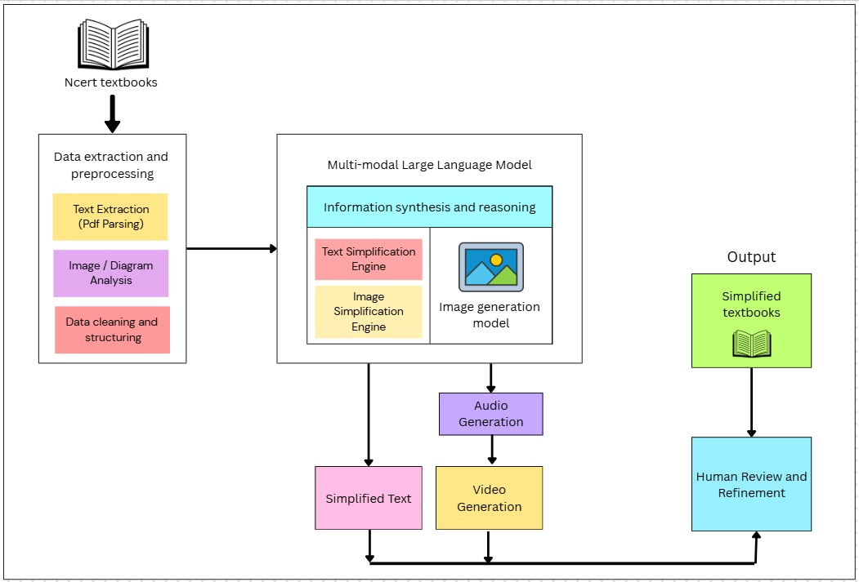
Fig. 1 : Block Diagram

As shown in Figure 1, the EduBridge framework follows a structured, five-stage pipeline that transforms standard NCERT textbooks into accessible, multimodal learning content for students with diverse learning needs.

Input Stage – NCERT Textbooks
The process begins with official NCERT textbooks containing complex academic content across subjects. These serve as the primary data source for simplification and content generation.

Data Extraction and Preprocessing

Text Extraction: PyMuPDF is used to parse PDFs, ensuring that the extracted content retains the original formatting and structure.

Image/Diagram Analysis: Visual elements such as diagrams are identified and extracted for contextual understanding.

Data Cleaning and Structuring: The extracted text and visuals are organized into a hierarchical JSON format, sorted by topic and subtopic for efficient processing.

Multi-modal Large Language Model

Information Synthesis and Reasoning: The Gemini model serves as the central AI engine, analyzing academic content and understanding educational context.

Text Simplification Engine: Converts complex textbook language into simplified explanations suitable for grades 4–5.

Image Simplification Engine: Enhances diagrams for better readability and accessibility.

Image Generation Model: Creates illustrative visuals to accompany simplified text.

Audio Generation: Produces text-to-speech narration for auditory learners.

Video Generation: Integrates text, visuals, and audio into educational video summaries.

Output – Simplified Textbooks
The processed outputs form multimodal educational material—including text, visuals, and audio—tailored to support students with learning disabilities and varying comprehension levels.

Human Review and Refinement
Before deployment, educators review the AI-generated content to ensure factual correctness, curriculum alignment, and pedagogical effectiveness.

4.2. Modular Diagram Representation of the Proposed System
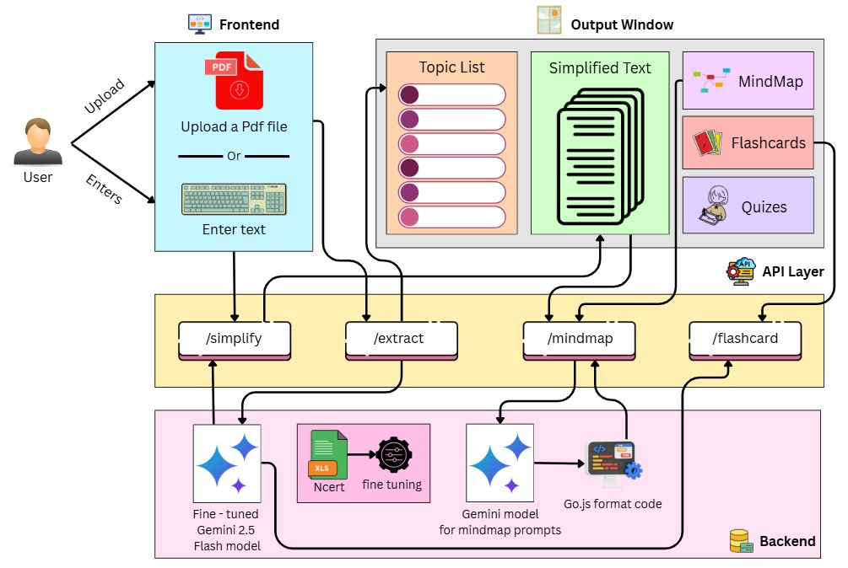
Fig. 2 : Modular Diagram

As shown in Figure 2, EduBridge integrates three core layers—Frontend, API Layer, and Backend—ensuring seamless data flow and real-time learning assistance.

User Interface (Frontend)

Input Methods: Users can either upload NCERT PDFs or manually enter text for simplification.

Output Components:

Topic List: Sidebar navigation displaying extracted topics.

Simplified Text: Main section showing AI-generated explanations.

MindMap: Interactive visual representation of hierarchical concepts.

Flashcards & Quizzes: Engaging learning aids for reinforcement and self-assessment.

API Layer (Middleware)
The middleware handles communication between the frontend and backend through RESTful APIs:

/simplify: Simplifies text for readability.

/extract: Structures content into a topic-based JSON format.

/mindmap: Generates visual mindmaps.

/flashcard: Produces question–answer pairs for learning recall.

Backend (Processing Engine)

Fine-tuned Gemini 2.5 Flash Model: Specialized for educational text simplification.

NCERT Fine-tuning: The model is trained on NCERT content to maintain contextual accuracy.

MindMap Generation: Gemini prompts create structured visual outputs, converted to Go.js format for rendering.

Integration: The backend ensures smooth data processing and real-time response to user inputs.

Data Flow
Information moves seamlessly from User Input → API Routing → AI Processing → Formatted Output, allowing real-time updates and personalized feedback.

4.3 Design of the Proposed System:

a. Data Flow Diagram

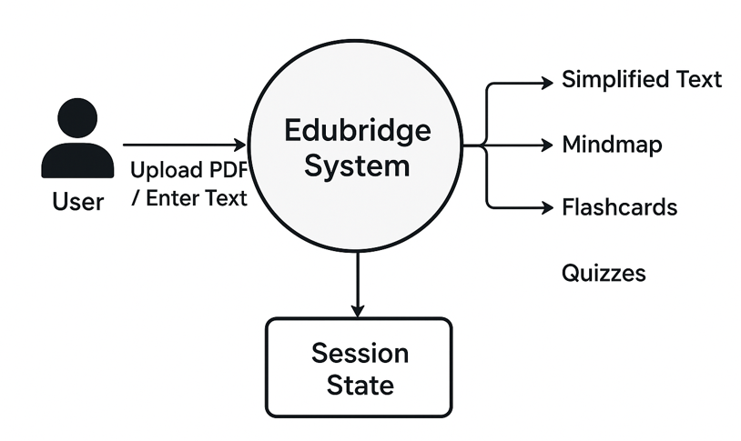
Fig. 03 : Data flow diagram

As shown in Figure 3, the Data Flow Diagram illustrates how data moves through various components of the EduBridge system—from user input to AI processing and final output generation.

User Input

The process begins when users upload NCERT textbook PDFs or manually enter text content.

This serves as the primary input for the system.

Data Extraction and Preprocessing

Extracts and segments textual content using PDF parsing tools.

Cleans and organizes the extracted material into topic-based structured formats for better processing.

AI Processing Layer

Text Simplification Engine: Transforms complex academic content into simple, child-friendly explanations.

MindMap Generator: Creates visual representations of key concepts with hierarchical connections.

Flashcard Generator: Extracts questions–answer pairs to promote active learning and recall.

Quiz Generator: Generates assessment-based questions for evaluating understanding.

Output Management Layer

Collects and formats the generated outputs (Simplified Text, Mindmaps, Flashcards, Quizzes).

Sends the processed content to the frontend for user viewing and interaction.

User Interface (Frontend)

Displays all outputs in an organized dashboard format.

Allows users to navigate between topics, view simplifications, and interact with learning tools.

Session State Management

Maintains user interactions, progress, and generated content for each session.

Enables users to revisit previous materials and ensure learning continuity.

b. Flowchart for the Proposed System
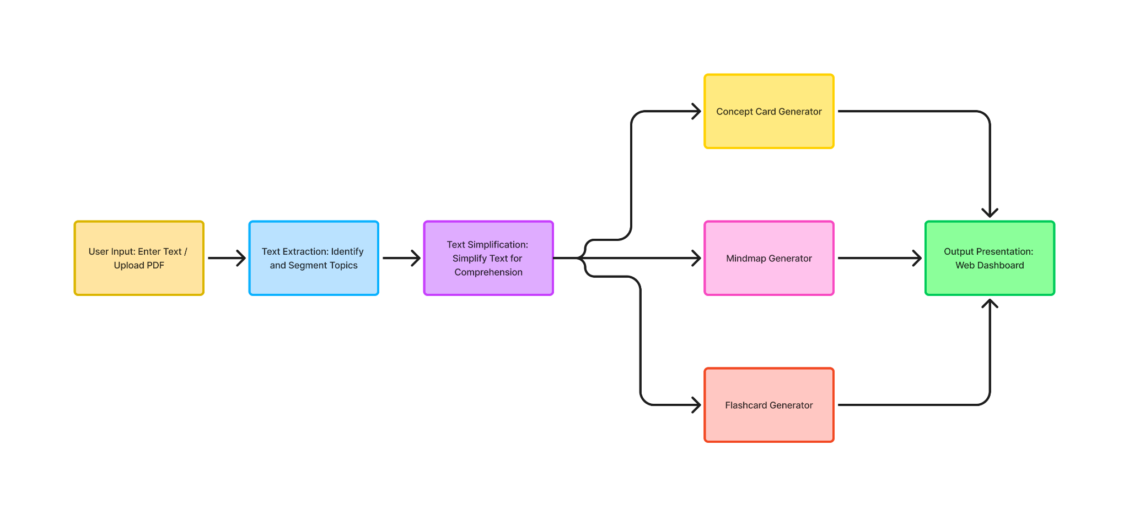
Fig. 4 : Flowchart

As shown in Figure 4, EduBridge functions as a centralized learning assistant that manages every stage of the educational content transformation pipeline.

User Input: Students upload textbooks or input text manually.

Text Extraction: AI identifies topics and sections using intelligent parsing.

Text Simplification: Complex text is rephrased into grade-appropriate language.

Parallel Output Generation:

Concept Cards: Highlight key ideas.

Mindmaps: Create hierarchical visual summaries.

Flashcards: Generate Q&A for active learning.

Output Presentation: The web dashboard presents all materials interactively—allowing students to explore topics, study through visual aids, and practice recall.

c. Screenshots of Implementation
As shown in Figure 5, the Home Page allows users to upload PDF files or paste text content to begin the simplification and learning process.
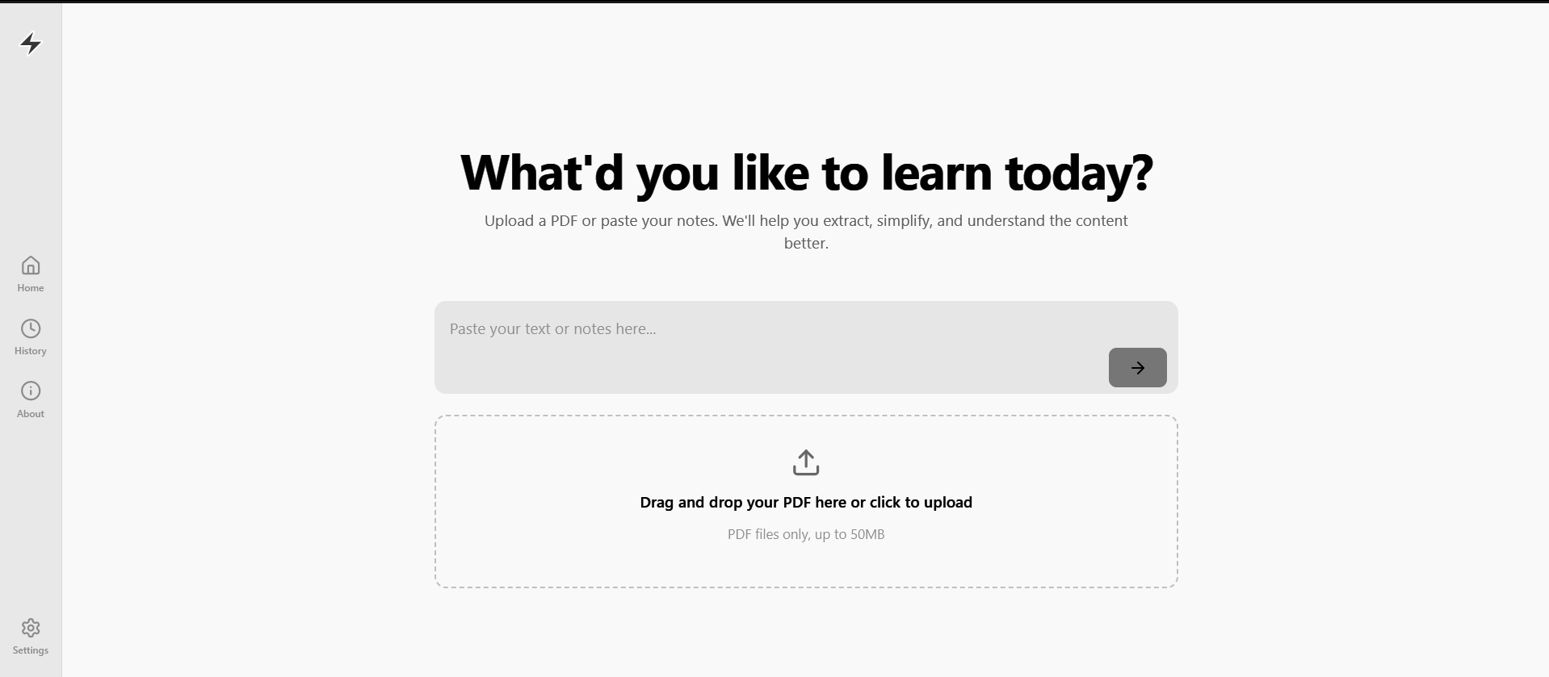
Fig. 5 : Home Page
As depicted in Figure 6, the Loading Screen displays the progress of topic simplification while the system processes educational content in real-time.
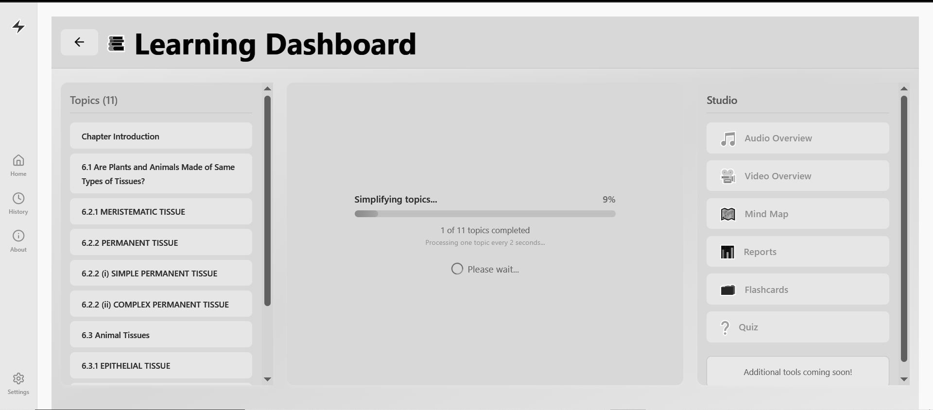
Fig. 6 : Loading Screen

As shown in Figure 7, the Simplified Text output presents child-friendly explanations of complex textbook content in a clear and structured format.
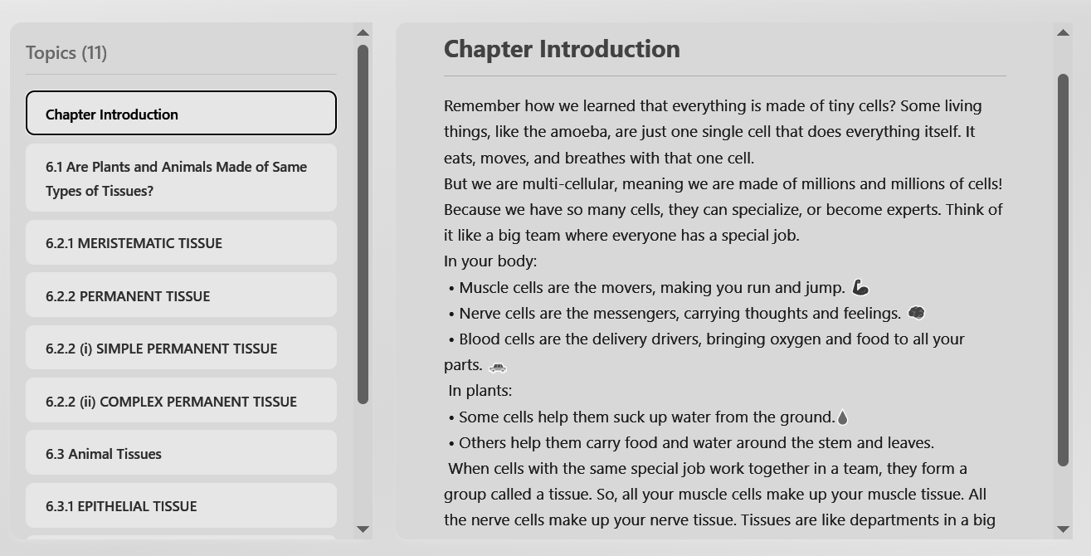
Fig. 7 : Output (Simplified Text)
As illustrated in Figure 8, the Mindmap output visually represents the hierarchical structure of concepts and their interconnections for better understanding.
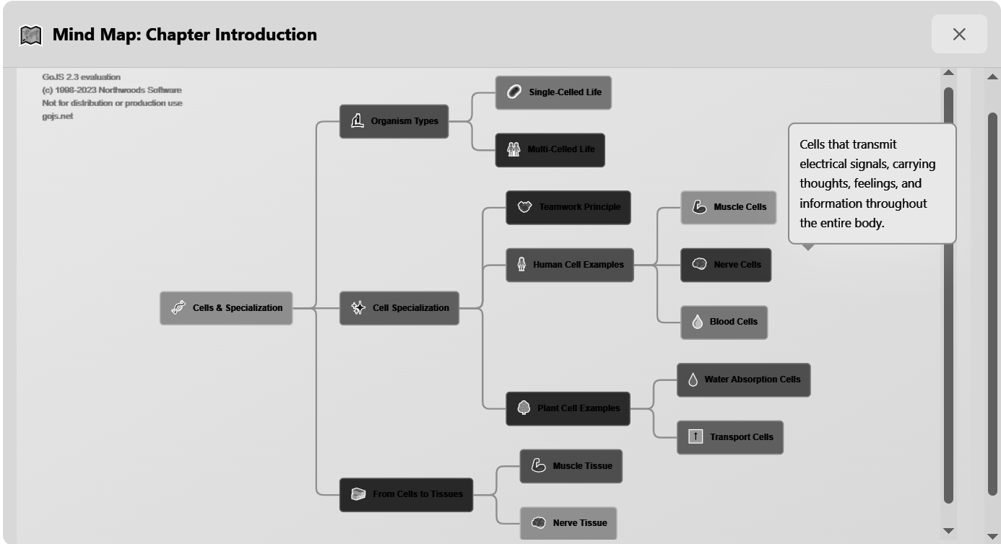
Fig. 8 : Output (Mindmap)
As shown in Figure 9, the Flashcards feature generates interactive question–answer pairs to help learners test and reinforce their understanding of the topic.
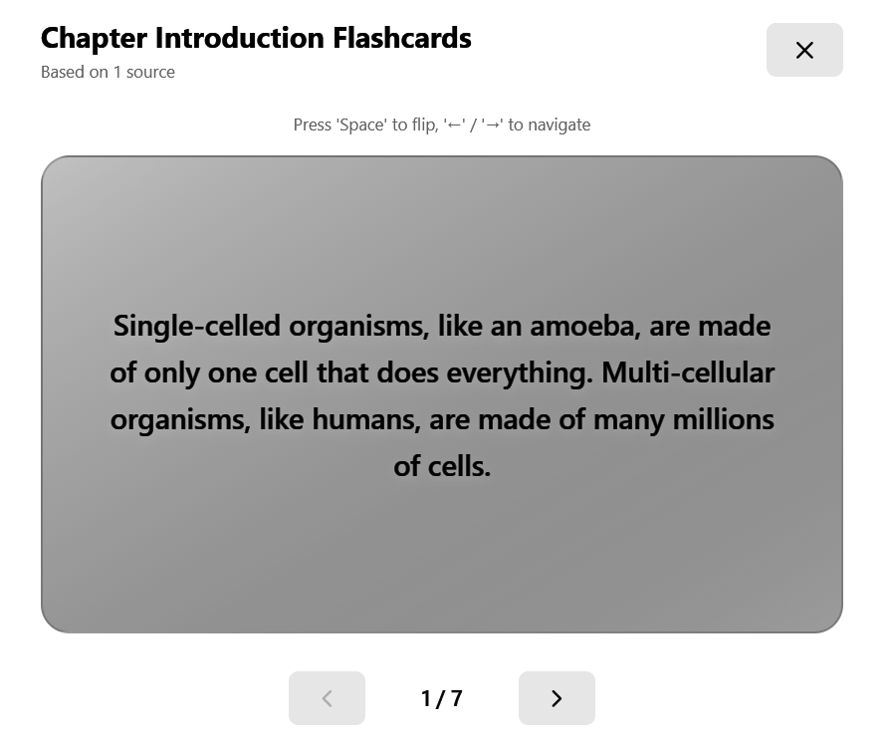
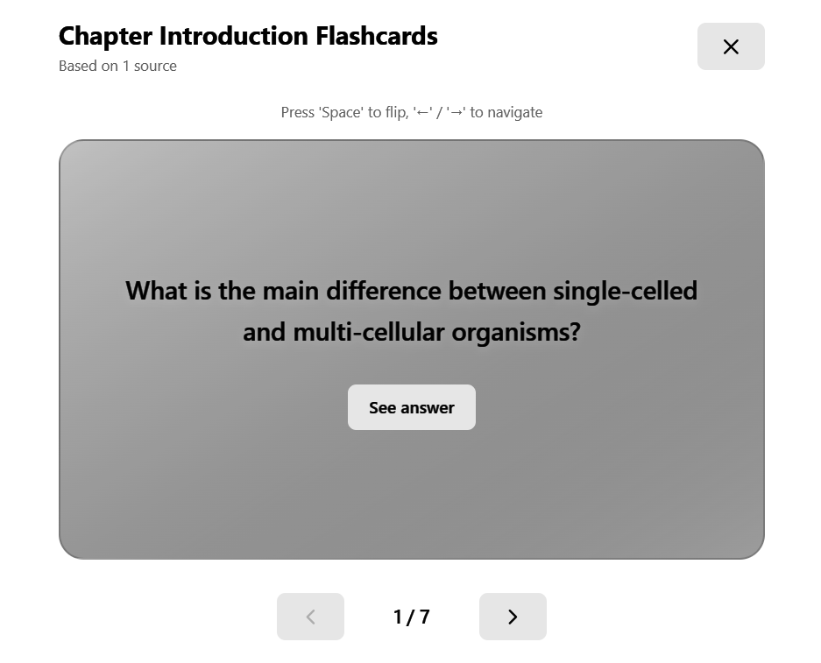
Fig. 9 : Output (Flashcards)

4.4. Project Scheduling & Tracking using Timeline / Gantt Chart
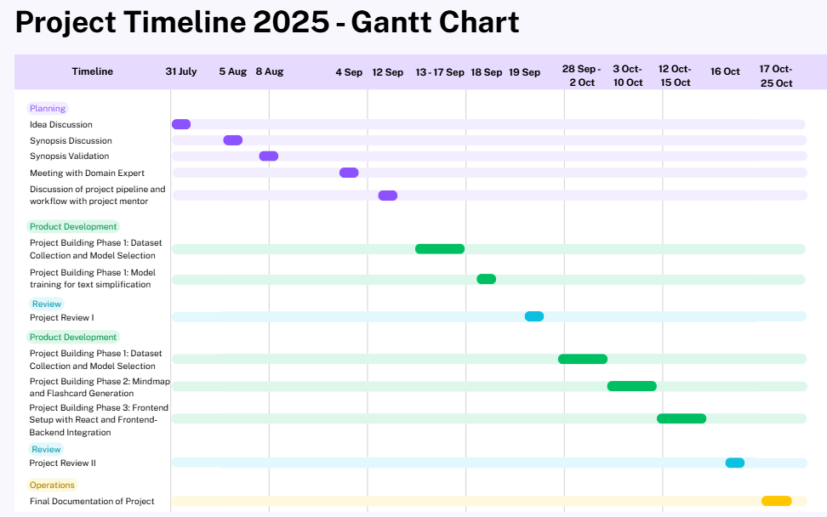
Fig. 10 : Gantt Chart

CHAPTER 5: PROPOSED RESULTS AND DISCUSSIONS
This chapter outlines the anticipated results and evaluation parameters for the system. It describes the expected outputs, efficiency metrics, and accuracy benchmarks that will be used to assess system performance. Analytical evaluations such as sensitivity analysis and comparative performance graphs (e.g., accuracy versus time) are proposed to measure the model’s reliability and effectiveness.

5.1 Proposed Output
The expected output of the system includes:
- Generation of simplified topic-wise notes from complex academic text.
- Creation of mind maps to represent hierarchical relationships between key concepts.
- Automatic development of flashcards for quick revision and memory retention.
- User-specific content recommendations generated by the agentic AI layer based on learning behavior and prior interactions.
- A visual and interactive frontend interface that allows learners to easily navigate, generate, and download study materials.
These outputs collectively aim to make the learning process engaging, adaptive, and inclusive for students of varied learning capabilities.

5.2 Evaluation Parameters
To assess the system’s performance, the following parameters will be used:
- Accuracy:
  - Measures how correctly the AI simplifies and summarizes text while preserving original meaning.
  - Formula:
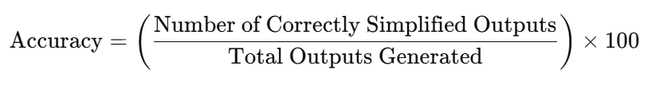

- Efficiency:
  - Represents the system’s ability to process and generate content within an optimal response time.
  - Formula:
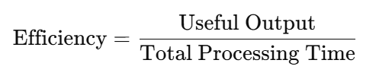
- Readability Index:
  - Determines how easily the simplified text can be understood by a target user group. Tools like the Flesch–Kincaid readability score or Gunning Fog Index may be applied.
- User Satisfaction Score:
  - Derived from feedback surveys evaluating clarity, usefulness, and overall learning experience.
  - Uses a 5-point Likert scale for quantitative analysis.
- Sensitivity Analysis:
  - Examines how changes in parameters (e.g., input text complexity, model configuration) affect output quality and response time.

5.3 Graphical Representations
The following graphs are proposed for result visualization and analysis:
- Accuracy vs. Time:
Depicts how system accuracy changes with increasing content complexity or volume.
- Processing Time vs. Input Size:
Demonstrates the system’s scalability and efficiency across datasets of varying lengths.
- User Satisfaction vs. Content Type:
Compares user ratings for different content formats (notes, mind maps, flashcards).
- Readability Score Comparison:
Shows improvement in comprehension level before and after simplification by EduBridge.

5.4 Expected Outcomes
- Achieve a content simplification accuracy of over 85% with semantic integrity maintained.
- Ensure average response time under 3 seconds per input.
- Improve readability levels by at least 30% for complex academic content.
- Gain positive user feedback indicating a more accessible and engaging learning experience.
These outcomes will validate the system’s contribution toward inclusive and adaptive education.

CHAPTER 6: PLAN OF ACTION FOR THE NEXT SEMESTER
This chapter summarizes the work completed thus far and presents a structured plan for the upcoming project phase. It outlines the milestones achieved during the first semester and specifies the objectives, tasks, and development activities planned for Project Phase II. The aim is to ensure a systematic continuation of the project, focusing on enhancement, evaluation, and final deployment.

6.1 Work Done Till Date
- Conducted a detailed problem analysis and formulated the project’s objectives, motivation, and methodology.
- Studied existing educational and NLP-based tools to identify their limitations.
- Designed the system architecture and initiated the development of key backend modules using Python and Flask.
- Implemented initial NLP-based text simplification and summarization prototypes using transformer-based models.
- Designed the frontend layout using React and Tailwind CSS to create a user-friendly interface.
6.2 Plan of Action for Project-II
The upcoming phase of the EduBridge project will focus on refining content quality, improving system intelligence, and enhancing user experience. The following tasks have been planned as part of the next stage of development:

1. Content Restructuring
The content generation process will be restructured to classify learning material into three progressive difficulty levels:
- Simple Level: Short, concise summaries for quick understanding.
- Intermediate Level: Descriptive explanations providing moderate conceptual depth.
- Advanced Level: Detailed discussions of core concepts, definitions, and examples.
This hierarchical content design will allow learners to choose their preferred learning depth and help educators adapt teaching materials accordingly.

2. Simplification Refinement
The existing text simplification model will be refined by distinguishing between extractive and abstractive simplification techniques. The results from both approaches will be compared with original textbook content to ensure factual accuracy, conceptual integrity, and alignment with academic standards.

3. User Interface Enhancement
The user interface will be improved for a more seamless and intuitive experience. Planned enhancements include:
- Introducing auto-predictive content suggestions for faster access to topics.
- Splitting flashcards into a distinct Question–Answer format for better self-assessment.
- Adding a sidebar navigation panel to organize notes, mind maps, and flashcards efficiently.
These upgrades aim to make the interface more consistent, accessible, and learner-friendly.

4. Stylometry-Based Simplification
Stylometry will be incorporated to guide the extractive simplification process. The system will identify and prioritize content segments based on the document’s hierarchical structure — Title > Subtitle > Content Body. This ensures that simplified material retains essential context and maintains logical flow across all learning levels.

5. Image Integration and Visual Q&A
The next iteration will introduce image extraction and visual-based question generation. Relevant images from educational content will be analyzed to produce corresponding question–answer pairs. This feature will promote visual learning and improve conceptual understanding, especially for visually oriented learners.

6. Download and Export Options
Functionality will be added to allow topic-wise downloads of generated content. Learners and educators will be able to export simplified notes and mind maps in PDF and DOCX formats. This feature will enhance accessibility and enable offline learning.

CHAPTER 7: CONCLUSION
The EduBridge project represents a meaningful step toward the development of inclusive and accessible education systems using artificial intelligence. By combining NLP, multimodal learning aids, and agentic AI, the framework strives to simplify academic content and make it comprehensible for all learners, including those with special educational needs.
The proposed system has the potential to address critical drawbacks in traditional educational methods—lack of personalization, accessibility barriers, and low engagement—by transforming static learning materials into adaptive, user-specific resources.
Upon completion, EduBridge is expected to demonstrate high efficiency, accuracy, and readability, validating its real-world applicability in educational institutions and e-learning environments. The project thus embodies the principle of technology for social good, where AI is harnessed not only to innovate but to empower learners and educators alike.

CHAPTER 8: REFERENCES
[1] Y. Hu, M. Chen, and L. Zhou, “Generative AI in Education: From Foundational Insights to the Socratic Playground for Learning,” IEEE Transactions on Learning Technologies, vol. 18, no. 2, pp. 112–124, 2025.
[2] J. Jabbour, R. Kumar, and E. Li, “SocratiQ: A Generative AI-Powered Learning Companion,” in Proceedings of the IEEE International Conference on Artificial Intelligence in Education (AIEd), pp. 45–52, 2025.
[3] S. Davalos, P. Mehta, and A. Singh, “LLMs as Educational Analysts: Transforming Multimodal Data Traces,” IEEE Access, vol. 13, pp. 48021–48035, 2025.
[4] C. Fang, Y. Tan, and K. Wong, “Collaborative AI-Enhanced Digital Mind-Mapping for Inclusive Education,” IEEE Transactions on Learning Technologies, vol. 17, no. 4, pp. 765–778, 2024.
[5] J. Wu, Z. Liu, and X. Wang, “NEXT-GPT: Any-to-Any Multimodal Large Language Model,” in Proceedings of the IEEE Conference on Multimodal AI Systems, pp. 118–126, 2024.
[6] J. Vásquez-Rodríguez, L. Martínez, and P. Ramos, “Simple Is Not Enough: Document-Level Simplification with Readability and Coherence,” IEEE Transactions on Language Processing, vol. 12, no. 3, pp. 233–247, 2024.
[7] J. Leiker, A. Brown, and S. Ghosh, “Prototyping LLMs for Adult Learning Content Creation,” in Proceedings of the IEEE Education Technology Conference, pp. 201–209, 2023.
[8] T. Alkaldi and D. Inkpen, “Text Simplification to Specific Readability Levels,” IEEE Transactions on Learning Technologies, vol. 16, no. 2, pp. 312–324, 2023.
[9] S. Rehman, “AI for Inclusive Education: Supporting Learners with Disabilities and Special Needs,” Asian International Journal of Education and Learning, vol. 5, no. 1, pp. 48–56, 2025.
[10] M. Akram, “AI for Inclusive Education: Comparative Insights and a Framework for Neurodiverse Learning,” International Journal of Creative Multimedia, vol. 6, no. 2, pp. 33–45, 2025.
[11] T. Ayeni, B. Olaleye, and F. Adebayo, “AI-driven Adaptive Learning Platforms: Enhancing Educational Outcomes for Students with Special Needs through User-Centric, Tailored Digital Tools,” World Journal of Advanced Research and Reviews, vol. 24, no. 2, pp. 101–112, 2024.
[12] A. Singh, “Intelligent Tutoring Systems and Adaptive Learning Environments: Teacher-Centric Method in AI-Augmented Classrooms,” Asian Education and Learning Review, vol. 3, no. 4, pp. 72–83, 2024.
CHAPTER 9: APPENDIX
9.1 List of Figures
Figure Number | Heading | Page no.
1 | Block Diagram | 25
2 | Modular Diagram | 27
3 | Data Flow Diagram | 29
4 | Flowchart | 31
5 | Homepage | 32
6 | Loading Screen | 32
7 | Output(Simplified Text) | 33
8 | Output(Mindmap) | 33
9 | Output(Flash Card) | 34
10 | Gantt Chart | 34

9.2 List of Tables
Table Number | Heading | Page no.
1 | Literature Survey | 12-14
2 | Differentiation from Existing Systems | 23-24

9.3 Research Paper

EduBridge: Agentic AI Framework for Inclusive Education

Sujata Khedkar  VES Institute of Technology  sujata.khedkar@ves.ac.in  Mohit Vaidya  VES Institute of Technology 2022.mohit.vaidya@ves.ac.in | Sarang Pavanaskar  VES Institute of Technology  2022.sarang.pavanaskar@ves.ac.in | Akshat Mahajan  VES Institute of Technology  2022.akshat.mahajan@ves.ac.in  Tanmay Maity  VES Institute of Technology  2022.tanmay.maity@ves.ac.in

The proposed system presents an AI-driven platform for transforming complex NCERT textbook content into accessible learning materials for students with learning disabilities. The system integrates five key stages: content extraction, text simplification, flashcard generation, mind map visualization, and quiz creation.To improve academic understanding and engagement, the system integrates multi-modal elements such as simplified text, visual mind maps, and interactive assessments.This approach demonstrates how generative AI can support inclusive education by automating the labor-intensive process of content adaptation and providing personalized, multi-sensory learning experiences for students with dyslexia, ADHD, and other learning challenges.
Keywords - Large Language Models, Generative AI, Text Simplification, Learning Disabilities, Educational Technology, Mind Map Generation, NCERT Curriculum, Accessibility.

I. Introduction
Students with learning disabilities face significant barriers in accessing standardized educational content, particularly NCERT textbooks used throughout Indian schools. Conditions such as dyslexia, ADHD, and processing disorders affect approximately 10-15% of the student population, yet educational materials remain largely inaccessible to these learners. These students often struggle with complex sentence structures, advanced vocabulary, and dense information presentation found in traditional textbooks. Traditional approaches to content adaptation—manual simplification by educators—are time-intensive, inconsistent across subjects, and difficult to scale for large student populations. With the advancement of

Artificial Intelligence (AI) and Large Language Models (LLMs), it is now possible to automate and enhance how educational content is adapted for diverse learners. AI-powered tools can process textbook chapters, identify key concepts, and regenerate content at appropriate reading levels while maintaining curriculum integrity. These technologies enable the creation of personalized learning materials that accommodate different learning styles through text, visual aids, and interactive elements.
The proposed system uses AI models like Google Gemini to generate simplified text and structured mind maps that align with NCERT curriculum standards. By leveraging fine-tuned language models, the platform ensures content remains educationally valuable while becoming significantly more accessible. The system also generates flashcards and quizzes to reinforce learning through active recall and spaced repetition techniques.
The main aim of this project is to make NCERT content easier to understand and more engaging for students with learning disabilities. By using AI to transform textbooks into multi-modal learning resources, the system addresses diverse cognitive needs while preserving essential educational outcomes. This paper explains the technical implementation of the Edubridge platform, including data preparation methods, model fine-tuning strategies, system architecture design, and experimental validation demonstrating effectiveness for target users.

II. Related Work

A. Text Simplification for Educational Content (2023)
Research by Martin et al. explored controllable text simplification using BART transformers, allowing specification of target readability levels. The system achieved Flesch-Kincaid Grade Levels between 6-8 by adjusting model parameters during generation. The approach used sequence-to-sequence architecture with attention mechanisms to preserve semantic meaning while reducing linguistic complexity.
Visual coherence was maintained through careful control of sentence restructuring and vocabulary replacement. While the system showed promise for general text simplification, it lacked domain-specific optimization for curriculum-aligned educational content. Performance varied significantly across technical subjects like mathematics and science, where specialized terminology required preservation. Additionally, the model's effectiveness depended heavily on the quality and diversity of training data, with limited examples from standardized educational frameworks like NCERT.

B. AI-Powered Learning Systems for Special Education (2022)
This study examined adaptive learning platforms for students with dyslexia using reinforcement learning algorithms. Researchers implemented personalized reading exercises that adjusted difficulty based on real-time performance metrics. The system tracked reading speed, comprehension accuracy, and error patterns to optimize content delivery.
The platform demonstrated significant improvements in reading fluency, with students showing 34% faster reading speeds after 12 weeks of use. However, the approach focused exclusively on reading skill development rather than curriculum content adaptation. Content creation remained manual, limiting scalability. The system also required extensive initial assessment periods to establish baseline performance levels, creating barriers to immediate deployment in classroom settings.

C. Automated Mind Map Generation Using Neural Networks (2024)
Research explored graph-based algorithms and neural networks for extracting key concepts from educational text and organizing them into hierarchical visual structures. The team used entity recognition and dependency parsing to identify relationships between concepts, then applied graph clustering algorithms to create node hierarchies.
The system generated mind maps with average branching factors of 3-5 nodes per level, suitable for comprehensive topic coverage. Visual layouts were optimized using force-directed graph algorithms. Challenges arose when processing lengthy documents, as automatically generated maps often became cluttered with excessive detail. The approach also struggled with maintaining consistent visual styling across different subject domains, and lacked integration of memory aids like emojis or color-coding schemes specifically designed for learning-disabled students.

D. Multi-Modal Learning Platforms for ADHD Students (2023)
Patel and Kumar developed a learning platform combining text, audio narration, and video animations to support students with attention deficit disorders. The system employed text-to-speech synthesis with adjustable speed and pitch, synchronized with visual content highlighting key information segments. Video components used animated characters and motion graphics to maintain engagement.
User studies with 45 ADHD-diagnosed students showed 42% improvement in information retention compared to text-only materials. The multi-sensory approach reduced cognitive load by distributing information across multiple processing channels. However, all content creation—text adaptation, audio recording, video production—remained manual processes requiring specialized personnel. This limitation prevented the platform from scaling to cover comprehensive curriculum content, restricting its use to select topics and short learning modules.

III. Model Construction
This section explains the model architecture and optimization process, which involves fine-tuning a large language model (LLM) to simplify educational content and using AI tools to generate interactive learning materials.


Fig 1. Block Diagram

A. Content Extraction
Raw text is extracted from NCERT textbook PDFs using PyMuPDF (fitz), a Python library for accurate text parsing. The extraction process preserves document structure by identifying chapter headings, subtopic titles, paragraphs, and page boundaries. Structural elements such as section numbers and topic hierarchies are maintained to ensure proper content organization.
The extracted text is then processed through Google Gemini to segment it into individual topics with corresponding content blocks. This segmentation creates a structured JSON dataset where each entry contains a topic identifier and its associated educational content, enabling topic-by-topic simplification and navigation.

B. Text Simplification Engine
The core simplification engine uses a fine-tuned Vertex AI endpoint of Gemini 2.5 Flash. The model receives original NCERT content and applies learned patterns to transform it into child-friendly language targeting Grade 4-5 reading levels.
The simplification process follows specific guidelines: using very simple and clear vocabulary, maintaining a positive and encouraging tone, incorporating everyday

life examples, explaining concepts step-by-step, and preserving essential curriculum terminology while providing explanations. The model adjusts sentence structure, replaces complex words with simpler alternatives, and breaks down compound concepts into digestible pieces.
Each simplification request is processed with a temperature setting of 0.3 to ensure consistency and accuracy. The system includes error handling that preserves original content as a fallback if simplification fails, ensuring students always have access to learning materials.

C. Mind Map Generation
Mind map generation integrates visual learning support using structured data processed by the Go.js diagramming library. The generation process ensures that visualizations align with the content's conceptual hierarchy and learning objectives. It begins with fine-tuned Gemini 2.5 Flash, which analyzes simplified text to identify main topics, subtopics, and supporting details.
The model creates structured JSON output containing nodes and links. Each node includes a unique key, concise text (3-5 words), a color from a predefined palette, a relevant emoji, and a brief description (10-15 words). Links define parent-child relationships between concepts, creating a hierarchical tree structure.
The system ensures consistency in visual design by maintaining a maximum depth of 3 levels and preferring wider structures over deep chains. This prevents cognitive overload for students with learning disabilities while maintaining comprehensive topic coverage.

D. Flashcard Generation
To support active recall and spaced repetition learning techniques, the system includes flashcard generation using Gemini 2.5 Flash. The model processes simplified content to identify key concepts and formulate them into question-answer pairs.
The generation process focuses on creating clear, simple questions that test understanding of essential concepts. Answers are limited to one sentence (maximum 15 words) to maintain clarity and prevent information overload. Each flashcard is tagged with its source topic, allowing students to focus practice on specific areas.
The generated flashcards can be reviewed within the application interface, providing an interactive study tool that reinforces comprehension through active engagement with the material.

Fig 2. Modular Diagram

IV. Pipeline

A. User Input Stage
Users access the web interface where they can choose between two input methods: uploading NCERT PDF files (up to 50MB) or directly entering text into a textarea. The frontend validates input format and file size before sending data to the backend.

B. Content Processing and Structuring
The Flask backend receives the input and routes it to appropriate handlers. PDF files are processed using PyMuPDF to extract raw text. Both text and PDF inputs are then sent to Google Gemini 2.5 Flash via OpenAI-compatible API endpoints, which analyze the content and structure it into topic-content pairs in JSON format. This segmentation enables organized navigation and targeted simplification.

C. Sequential Simplification
The structured topics are displayed in the frontend sidebar. The system then initiates sequential simplification, processing each topic individually through the Vertex AI endpoint with 2-second intervals between requests to respect API rate limits. Progress is tracked in real-time with percentage-based indicators shown to users. Each successfully simplified topic is displayed immediately, while errors trigger retry mechanisms that preserve original content as fallback.
D. Interactive Learning Module Generation
After simplification completes, users can trigger generation of additional learning resources. Flashcard generation analyzes simplified content to create question-answer pairs. Mind map generation processes topic hierarchies to produce structured JSON with nodes and links, which the frontend renders using Go.js visualization.
E. Output and User Interaction
The final content is accessible through a three-panel dashboard. The left sidebar displays the topic list for navigation. The main content area shows simplified text with options to view original content or retry simplification for failed topics. The right sidebar provides access to studio tools including flashcards and mind maps. Users can navigate between topics seamlessly, with all generated content persisting throughout the session. Error states are clearly indicated with retry buttons, ensuring a smooth user experience even when API requests fail.

V. Results
The Home Page allows users to upload PDF files or paste text content to begin the simplification and learning process.
Fig 3. Home Screen
The Loading Screen displays the progress of topic simplification while the system processes educational content in real-time.

Fig 4. Loading Screen

Fig 5. Story Simplified
The Simplified Text (Fig 5) output presents child-friendly explanations of complex textbook content in a clear and structured format.


Fig 6. Mindmap

The Mindmap output visually represents the hierarchical structure of concepts and their interconnections for better understanding.

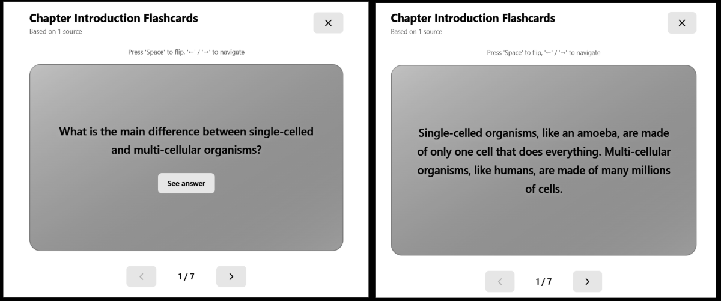

Fig 7. Flashcards

The Flashcards feature generates interactive question–answer pairs to help learners test and reinforce their understanding of the topic.

VI. Conclusion
The EduBridge project represents a significant step toward integrating Agentic Artificial Intelligence into the domain of inclusive education. Through its multi-agent framework, the system demonstrates how AI can be leveraged to create adaptive, accessible, and empathetic learning experiences tailored to the diverse needs of learners, including those with cognitive and linguistic challenges.
The project successfully implemented a pipeline encompassing data acquisition, NLP-based text processing, multimodal content generation, and user-centered interface design, ensuring both technical robustness and pedagogical relevance. By incorporating multimodal learning and accessibility-focused design, EduBridge bridges the gap between traditional learning environments and next-generation AI-driven education platforms.
Industry collaboration with Mr. Nikhil Mhatre (AI Overlords) provided invaluable real-world insights that enhanced the project’s alignment with practical educational needs, while academic guidance from our faculty ensured methodological rigor and research integrity.
In essence, EduBridge not only highlights the transformative potential of AI in education but also reinforces the importance of human-centered design and ethical AI deployment.

VII. Acknowledgements
We express our deepest gratitude to our guide, Dr. Sujata Khedkar, for their continuous support, valuable feedback, and insightful guidance throughout the course of this project. Their encouragement and expert supervision have been instrumental in helping us successfully conceptualize and implement EduBridge: Agentic AI Framework for Inclusive Education.
We would also like to extend our sincere appreciation to Mr. Nikhil Mhatre from AI Overlords for his invaluable mentorship and industry collaboration. His expertise in artificial intelligence and educational technology provided critical direction to our work. The insights shared during the consultation session helped us align our AI-driven framework with real-world pedagogical needs, especially for learners with cognitive and linguistic challenges. His structured approach—encompassing data acquisition, NLP-based processing, multimodal content generation, and user-centered interface design—greatly refined our project’s technical roadmap and enabled EduBridge to evolve into an industry-collaborated initiative.
We are thankful to the Head of the Department, Dr.Nupur Giri, the Department of Computer Engineering, Vivekanand Education Society’s Institute of Technology, for their constant encouragement, infrastructure support, and for fostering an environment of innovation and research.

VIII. References
[1] M. Alabdulrahman, R. Khayyat, K. Almowallad, and Z. Alharz, “Sarid: Arabic storyteller using a fine-tuned LLM and text-to-image generation,” in 2024 16th International Conference on Computer and Automation Engineering (ICCAE), 2024.
[2] C. Gou, A. Felemban, F. F. Khan, D. Zhu, J. Cai, H. Rezatofighi, and M. Elhoseiny, “Deep learning methodology converts text to image,” in Proceedings of the International Conference on Computer Vision and Pattern Recognition (CVPR), 2022.
[3] H. Chang, H. Zhang, J. Barber, A. J. Maschinot, J. Lezama, J. Lu, M.-H. Yang, K. Murphy, W. T. Freeman, M. Rubinstein, Y. Li, and D. Krishnan, “Muse: Text-to-image generation via masked generative transformers,” arXiv preprint arXiv:2301.00704, 2023.
[4] J. Wei, L. Wang, and D. Li, “LLM-DetectAIve: A tool for fine-grained machine-generated text detection,” arXiv preprint arXiv:2408.04284v1, 2024.
[5] J. Shen, J. Mire, H. W. Park, C. Breazeal, and M. Sap, “HEART-felt narratives: Tracing empathy and narrative style in personal stories with LLMs,” arXiv preprint arXiv:2405.17633, 2024.
[6] X. Hu, Y. Shen, Z. Tan, R. Yang, and J. Yang, “LoRA: Low-Rank Adaptation of Large Language Models,” arXiv preprint arXiv:2106.09685, 2021.
[7] R. Khapra, P. Bhowmick, A. Kunchukuttan, and M. Murthy, “MuRIL: Multilingual Representations for
Indian Languages,” arXiv preprint arXiv:2103.10730, 2021.
[8] H. Chang, H. Zhang, J. Barber, A. J. Maschinot, J. Lezama, J. Lu, M.-H. Yang, K. Murphy, W. T. Freeman, M. Rubinstein, Y. Li, and D. Krishnan, “Muse: Text-to-image generation via masked generative transformers,” arXiv preprint arXiv:2301.00704, 2023.
[9] Z. Zheng, B. He, and H. Lin, “Cross-lingual conversational speech summarization with large language models,” arXiv preprint arXiv:2408.06484, 2024
[10] H. Wang, Y. Liu, and X. Sun, “CT-Eval: Benchmarking Chinese text-to-table performance in large language models,” arXiv preprint arXiv:2405.12174, 2024.
[11] J. Shen, J. Mire, H. W. Park, C. Breazeal, and M. Sap, “HEART-felt narratives: Tracing empathy and narrative style in personal stories with LLMs,” arXiv preprint arXiv:2405.17633, 2024.
[12] J. Wei, L. Wang, and D. Li, “LLM-DetectAIve: A tool for fine-grained machine-generated text detection,” arXiv preprint arXiv:2408.04284v1, 2024.
[13] S. Zhang, Y. Chen, and T. Liu, “LLaVA-Surg: Towards multimodal surgical assistant via structured surgical video learning,” arXiv preprint arXiv:2408.07981, 2024.

9.4 Review 1: Evaluation Sheet
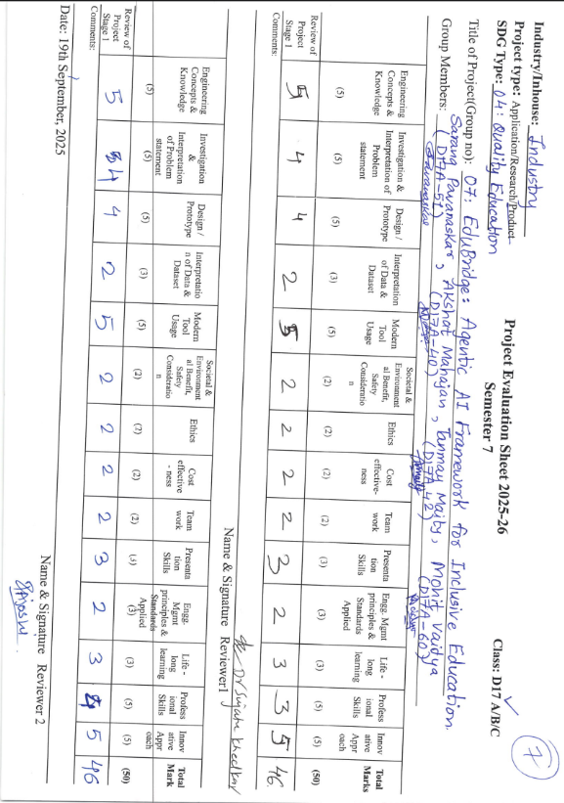
9.5 Review 2: Evaluation Sheet
